# 1.0 Cloud Architecture Diagram

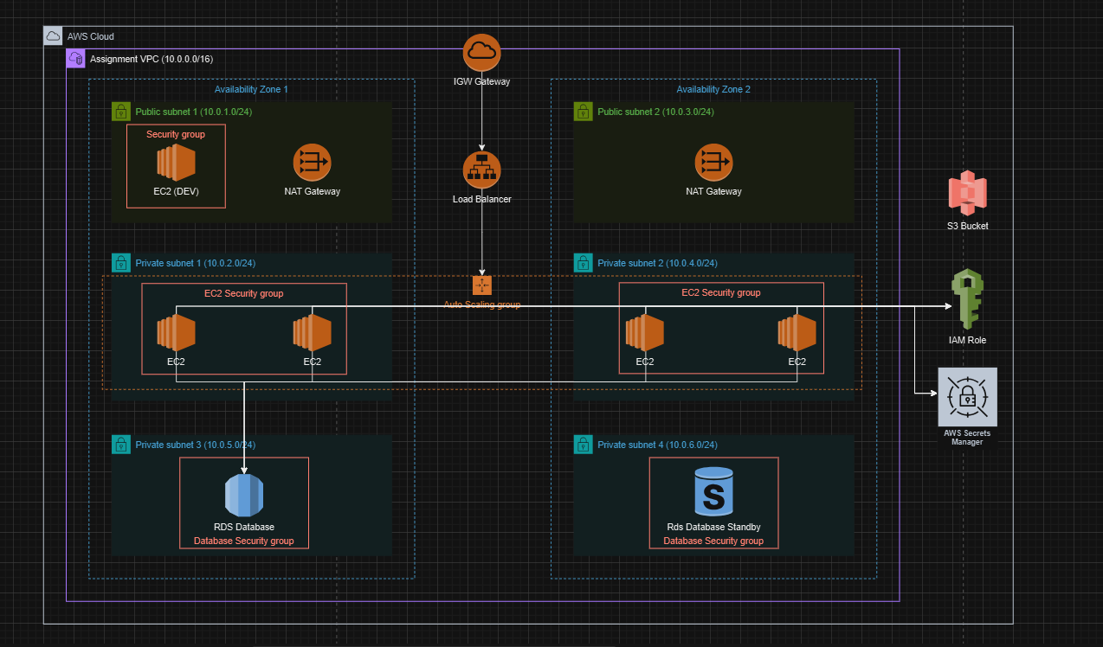

Figure 12: Cloud architecture diagram

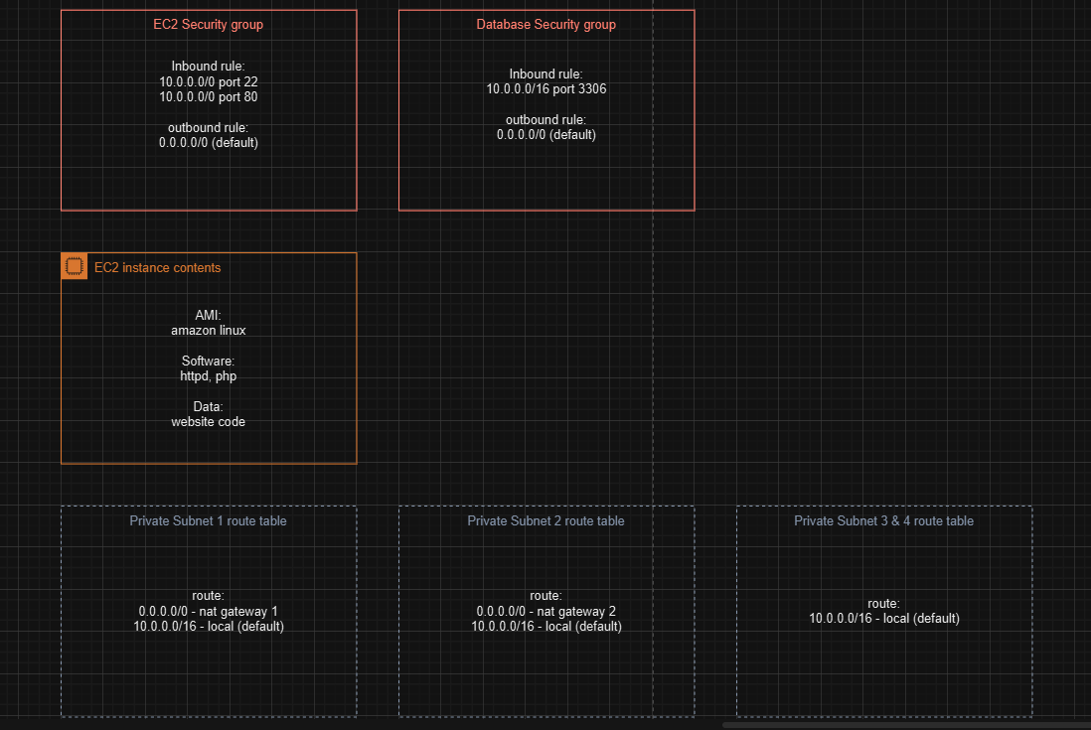

Figure 13: Security group and route table

# 2.0 Instructions to Construct the Cloud Architecture

## Phrase 1: Creating a basic functional web application

**Task 1: Create a virtual network (VPC, Internet gateway, NAT gateways, subnets, routes)**

1. At the top of the AWS Management Console, in the search bar, search for and choose VPC
2. Choose Create VPC, and configure the following:

* **Resources to create:** Choose **VPC only**
* **Name tag:** Enter “CinemaWebVPC”
* **IPv4 CIDR:** Enter “10.0.0.0/16”
* Choose **Create VPC**

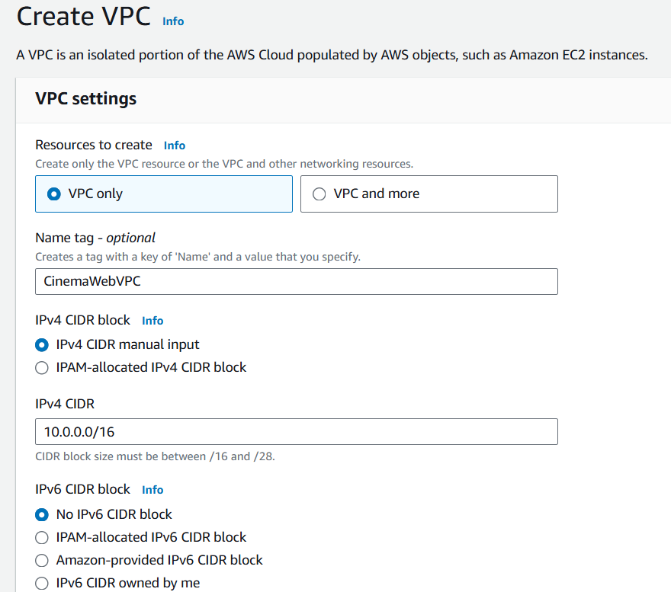

Figure 14: VPC setup

1. Update the settings for the VPC:
   * Choose **Actions** > **Edit VPC settings**.
   * In the **DNS settings** section, select **Enable DNS hostnames**.
   * Choose **Save**.

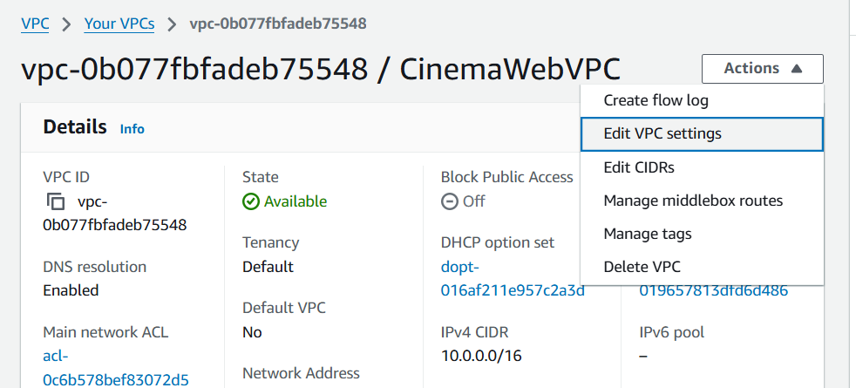

Figure 15: Editing VPC

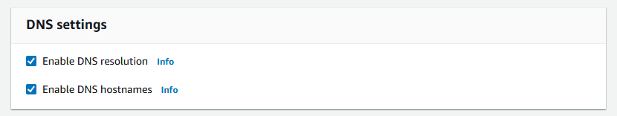

Figure 16: VPC: Enable dns setting

1. In the navigation pane, choose **Internet gateways**, and configure the following:

* Choose **Create internet gateway**
* **Name tag:** Enter “CinemaWeb-IGW”
* Choose **Create internet gateway**

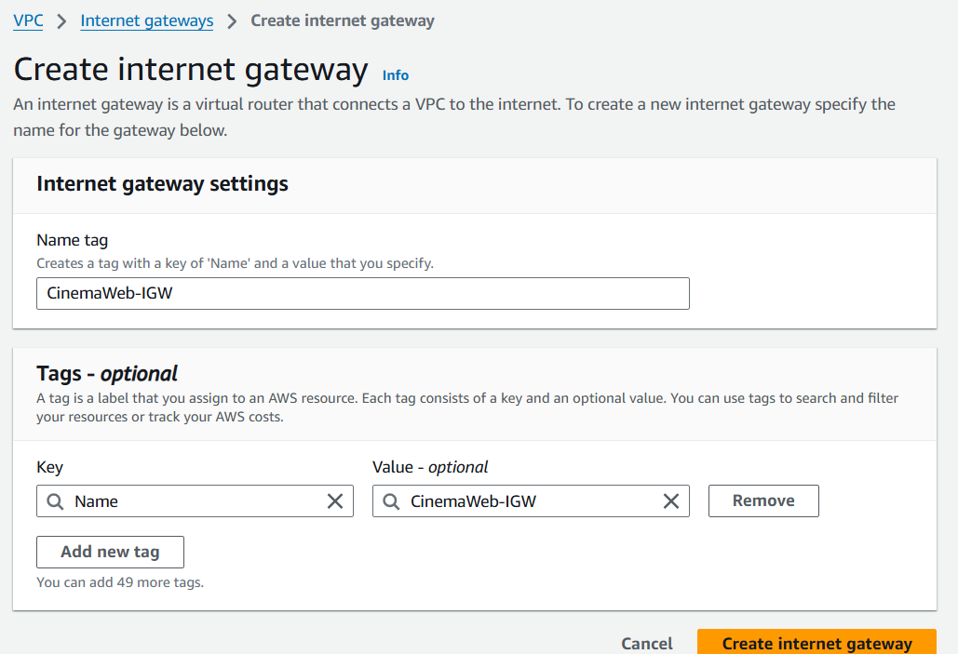

Figure 17:Creating NAT gateway

1. Attach the internet gateway to the VPC:

* Choose **Actions** > **Attach to VPC**
* **Available VPCs:** Choose **“**CinemaWebVPC**”**
* Choose **Attach internet gateway**

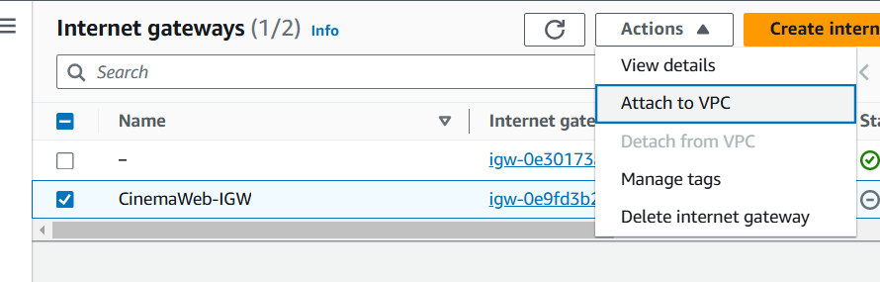

Figure 18:Attach internet gateway

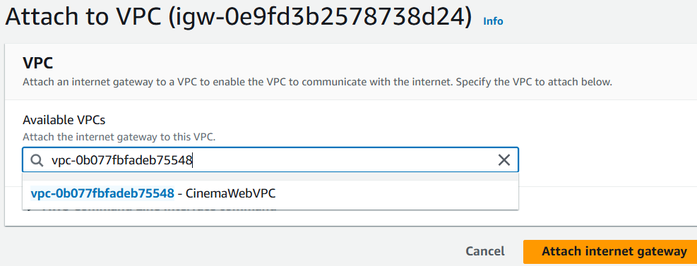

Figure 19:Attach to vpc

1. In the navigation pane, choose **Subnets**, and configure the following:

* Click **Create subnet**.
* **VPC ID:** Choose **“**CinemaWebVPC**”**
* **Subnet name:** Enter “Public Subnet 1”
* **Availability Zone:** Choose “ap-southeast-1a”
* **IPv4 CIDR block:** Enter 10.0.1.0/24
* Choose **Create subnet**.

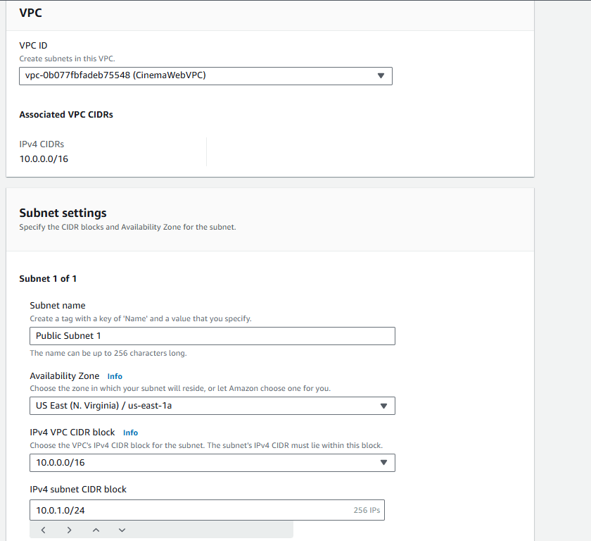

Figure 20:Creating of Public Subnet 1

Public Subnet 1 hosts EC2 instances for development (DEV) and a NAT Gateway.

1. Repeat the same steps for creating another 5 subnets following the table below:

|  |  |  |
| --- | --- | --- |
| **Subnet Name** | **Availability Zone** | **IPv4 subnet CIDR block** |
| Public subnet 2 | ap-southeast-1b | 10.0.3.0/24 |
| Private subnet 1 | ap-southeast-1a | 10.0.2.0/24 |
| Private subnet 2 | ap-southeast-1b | 10.0.4.0/24 |
| Private subnet 3 | ap-southeast-1a | 10.0.5.0/24 |
| Private subnet 4 | ap-southeast-1b | 10.0.6.0/24 |

Public subnet 2 hosts a NAT Gateway

Private subnet 1 & Private subnet 2 host EC2 instances created by automated scaling.

Private subnet 3 hosts the primary RDS database.

Private subnet 4 hosts the RDS database standby instance.

1. **Create route tables for public subnets:**

In the navigation pane, choose **Route tables**, then click “Create route tables” and configure the following:

* Name it as “Public-RT”, and selects “CinemaWebVPC”, then click “Create route table”
* In the route tables list, choose the Public-RT
* On the **Routes** tab (in the lower pane), choose **Edit routes**.
* Choose **Add route**, and add the following route:
  + **Destination:** Enter “0.0.0.0/0”
  + **Target:** Enter “Internet Gateway” and then choose “CinemaWeb-IGW”.
* Choose **Save changes**.

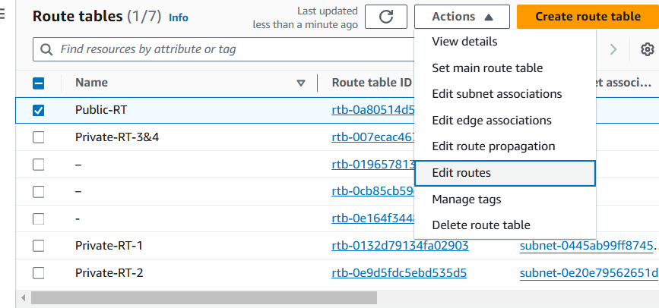

Figure 21:Edit routing

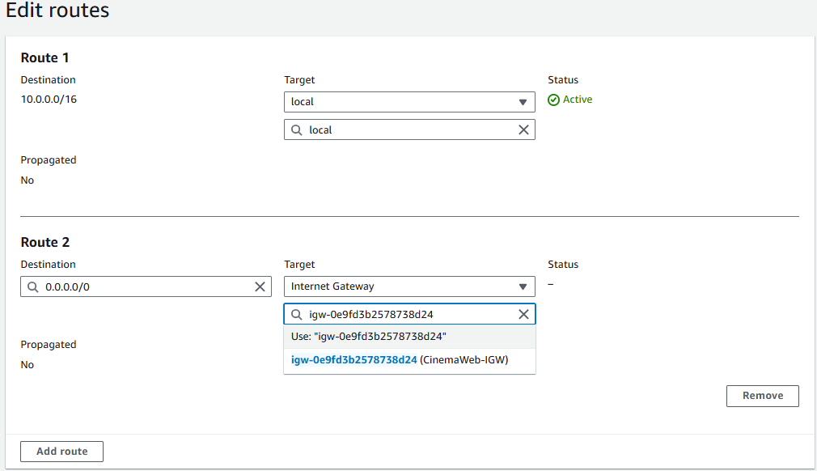

Figure 22: Routing configuration

1. **Create NAT Gateway 1:**

* Give name as “NAT-Gateway-1”
* Choose Public subnet 1 as subnet choice
* Connectivity type is Public
* Make sure to click the “allocate elastic IP”. Then, click “Create NAT gateway”.

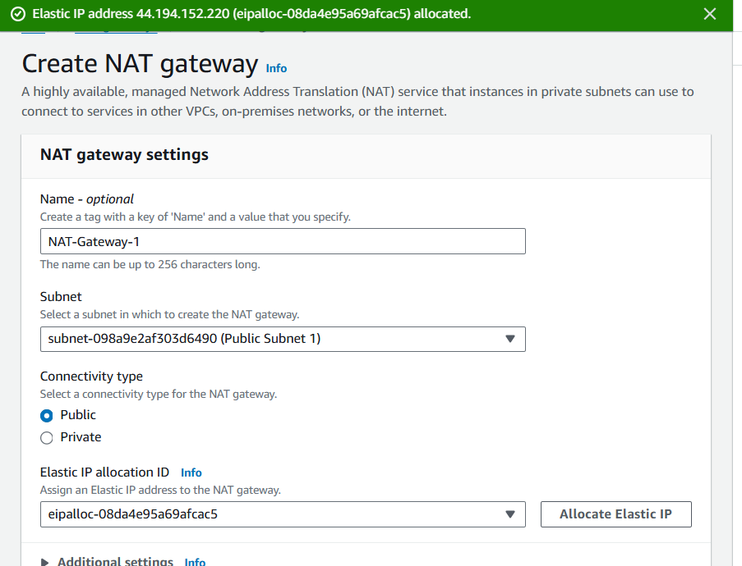

1. **Create NAT Gateway 2:**

* Give name as “NAT-Gateway-2”
* Choose Public subnet 2 as subnet choice
* Connectivity type is Public
* Make sure to click the “allocate elastic IP”. Then, click “Create NAT gateway”.

1. **Create route tables for Private subnet 1, Private subnet 2:**

In the navigation pane, choose **Route tables**, then click “Create route tables” and configure the following:

* Name it as “Private-RT-1”, and selects “CinemaWebVPC”, then click “Create route table”
* In the route tables list, choose Private-RT-1
* On the **Routes** tab (in the lower pane), choose **Edit routes**.
* Choose **Add route**, and add the following route:
  + **Destination:** Enter “0.0.0.0/0”
  + **Target:** Enter “NAT Gateway 1” and then choose “CinemaWeb-IGW”.
* Choose **Save changes**.
* Repeat this for creating Private-RT-2 with the same configuration as Private Subnet 1, but targeting "NAT Gateway 2".

1. **Create route tables for Private subnet 3 and Private subnet 4:**

In the navigation pane, choose **Route tables**, then click “Create route tables” and configure the following:

* Name it as “Private-RT-3&4”, and selects “CinemaWebVPC”, then click “Create route table”
* In the route tables list, choose Private-RT-3&4.
* On the Routes tab, confirm that only one route is listed and that it has the following settings:

1. Destination is 10.0.0.0/16.
2. Target is local.
3. In the navigation pane, choose **Subnets**, and configure the following:

* Select **Public Subnet 1**.
* Choose **Actions** > **Edit subnet settings**.
* In the **Auto-assign IP settings** section, select **Enable auto-assign public IPv4 address**.
* Choose **Save**.
* Repeat this for Public Subnet 2.

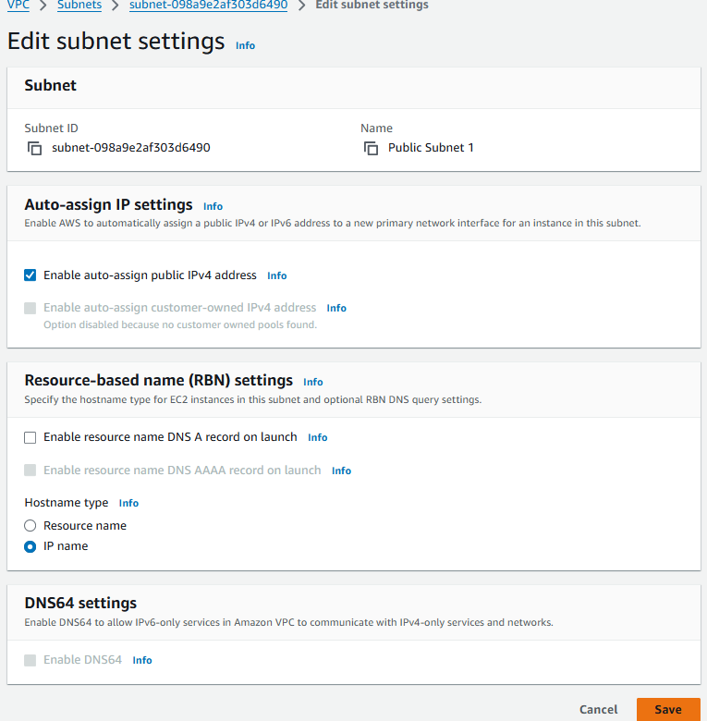

Figure 23:Enable auto assign IP setting

**Task 2: Creating a virtual machine (EC 2)**

1. At the top of the AWS Management Console, in the search bar, search for and choose EC2
2. Choose **Launch instance** > **Launch instance**, and then configure the following:
3. In the **Name and tags** section, for **Name**, enter “CinemaDevServer”
4. In the **Application and OS Images** section, under **Quick Start**, choose **Amazon Linux**.
5. In the **Instance Type** section, choose “t3.2xlarge”.
6. In the **Key pair** section, create new key pair and enter key pair name “DevServerKey”. (remember to save the key pair file)
7. In the **Network settings** section, configure the following:
   * Choose **Edit**.
   * **VPC:** Choose **CinemaWebVPC**.
   * **Auto-assign public IP:** Choose **Enable**.
   * **Firewall (security groups):** Choose **Create security group**.
   * **Security group name:** Enter “CinemaDevServer-SG”
   * Choose **Add security group rule**.

* Keep the existing SSH rule, and add two new rules with the following settings:
* **New rule 1:** For **Type**, choose **HTTP**. For **Source type**, choose **Anywhere**.
* **New rule 2:** For **Type**, choose **MYSQL/Aurora**. For **Source**, enter 10.0.0.0/16

1. Go to the **Advanced details** section. For the IAM role, choose the “LabInstanceProfile”.
2. Keep the default values for all other settings and choose **Launch instance**.

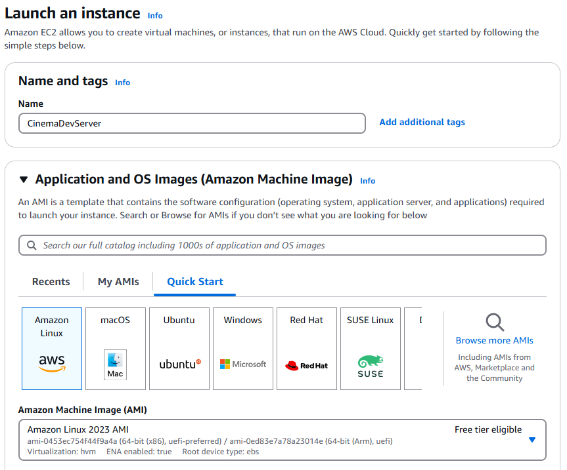

Figure 24:Launching Cinema Dev Server

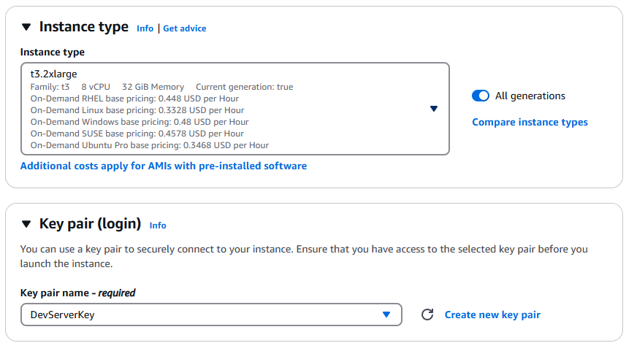

Figure 25: Selection of instance type

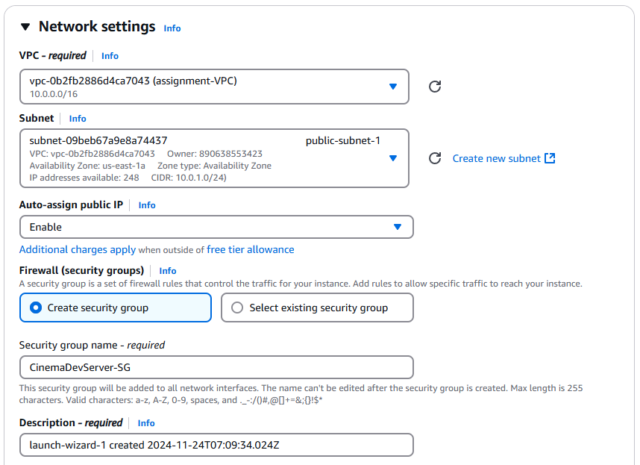

Figure 26:Firewall security set up rule

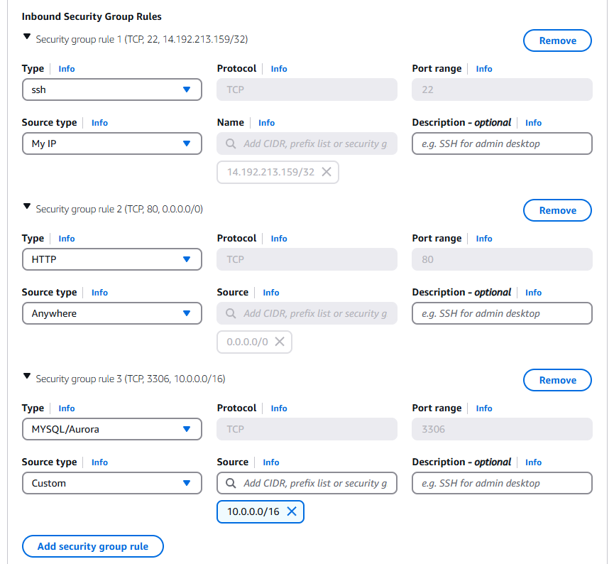

Figure 27:Security group setup rule

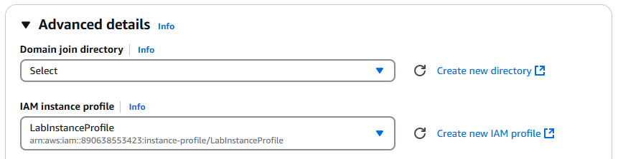

Figure 28: Assigning IAM profile

1. After the instance is created and its status is in running status,
   * Go to navigation pane, choose **Elastic IP addresses**
   * Click **Allocate Elastic IP address**
   * Click **Allocate** (One ip address will be generated)
2. Then, go back to the Elastic Ip addresses page, and click “Allocate Elastic IP address” then choose the instance we just created “CinemaWebServer”. (Now, the CinemaWebServer instance’s IP address will be always same as the elastic address you allocated to it. This serve as a static ip address which is good for easier management because even after the instance being stopped and restarted, the instance will remain the same public IP address.)

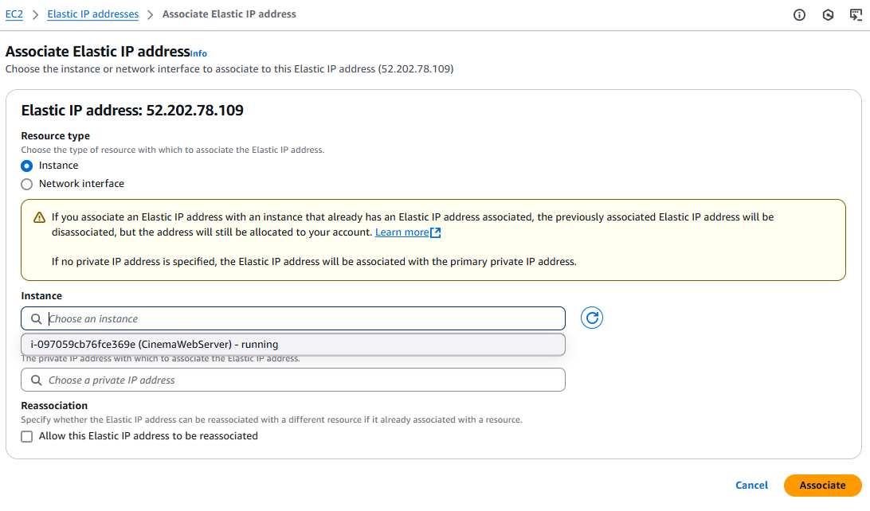

**Task 3: Setup ec2 environment and testing.**

1. We have to edit our website source code to ensure it can work well with the aws environment. So, we will be using AWS Secret Manager to store our environment variables. We will be using AWS PHP SDK to retrieve those variables in our php code.

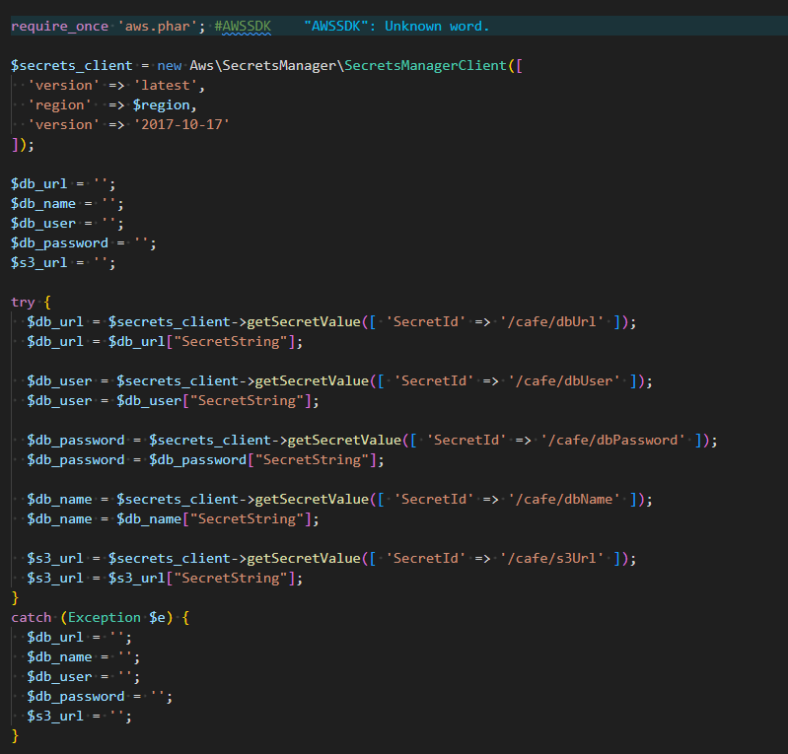

Figure 29:EC2 environment testing

1. Since later we will store all the images in S3 bucket, so some changes needed to be done to make sure the website can access, upload, remove images from S3 bucket. We need to modify image src path to accept dynamic URL.



Figure 30:Modify source in php

1. Now, we will set up ec2 environment to hosting our website. We will be using SSH to connect the ec2 instance. (This instruction will be using OpenSSH command, windows 10 build 1809 & above and windows 11 have built-in OpenSSH)
2. Open Terminal, then connect to the EC2 Instance by typing “**ssh -i “<file path of downloaded SSH key>” ec2-user@<your-ec2-ip-address>**”

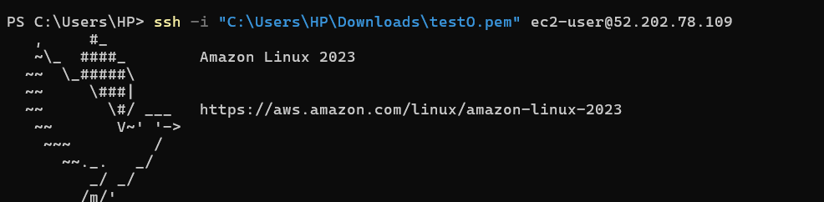

1. After successfully connecting to the ec2, exit the ec2 by typing “**exit**”. Now we need to upload source code of the website to ec2. Direct to the directory where you stored the ssh key file and zip file of source code, type “**scp -i "<file path of downloaded SSH key> " "<file path of the zip file>" ec2-user@<your-ec2-ip-address>:~”**



1. After transferring the zip file to EC2, connect to the EC2 Instance again. Then execute the following command.

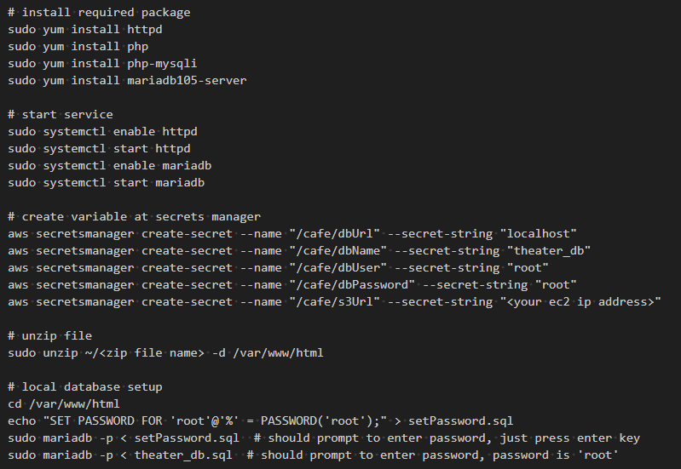

Figure 31:Configuration in Open SSH by using the .pem key file

1. After executing the command above, the ec2 environment should be complete setup. Now you can go to web browser and navigate to “http://<your ec2 ip address>”. You should be able to see the website.

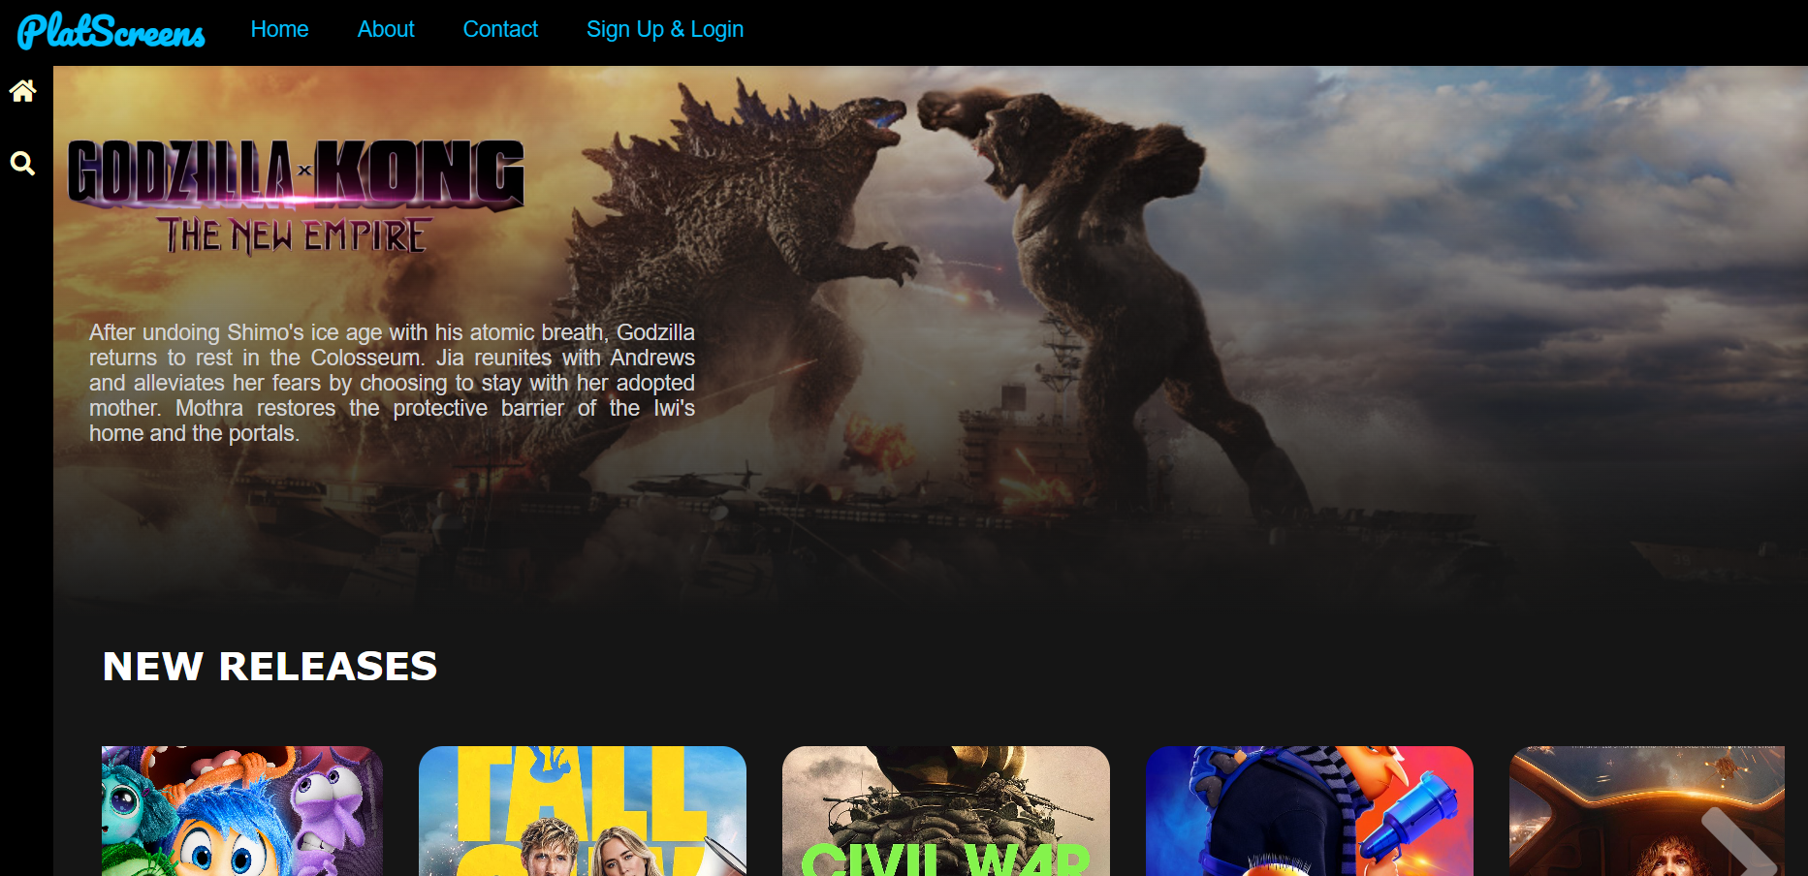

Figure 32: Movie booking platform website

* In the user page, ensure that you can register account, login account, see the most up-to-date movie information, book movie from the website, view your booking history, manage your user profile and change password.

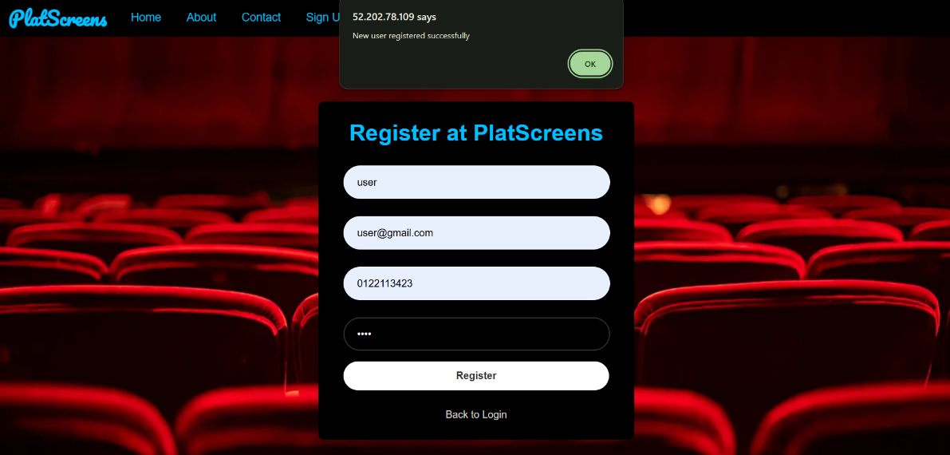

Figure 33:User registration in our platform

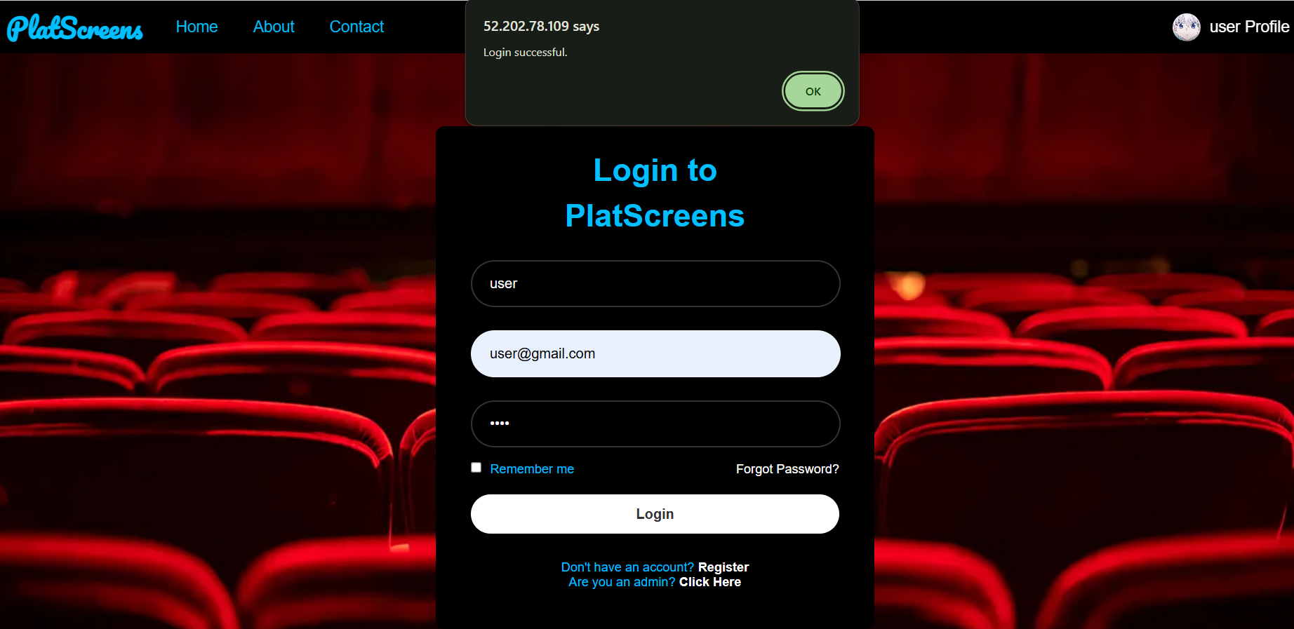

Figure 34:Signing in with existing user details in our platform

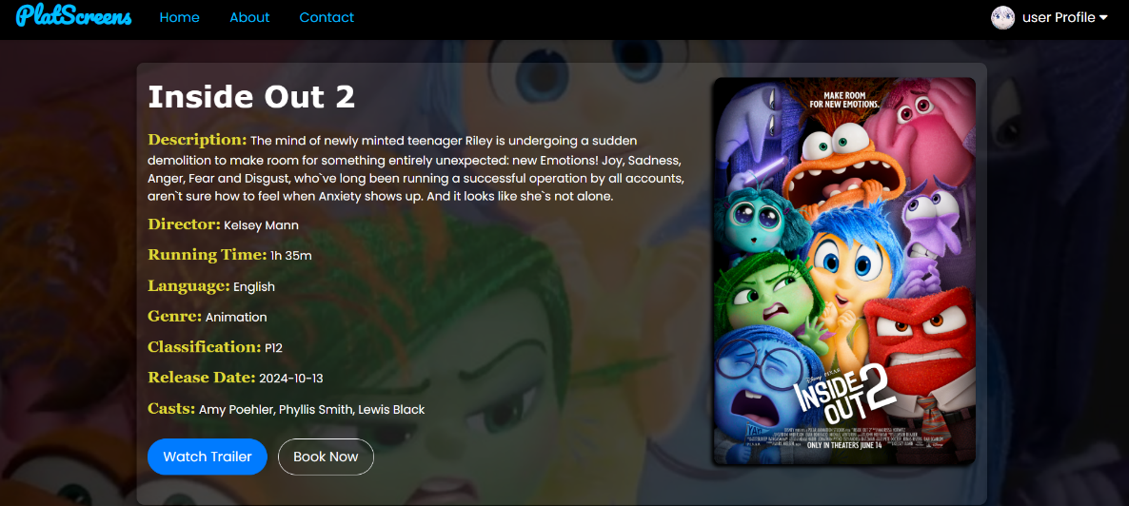

Figure 35:browsing movie details

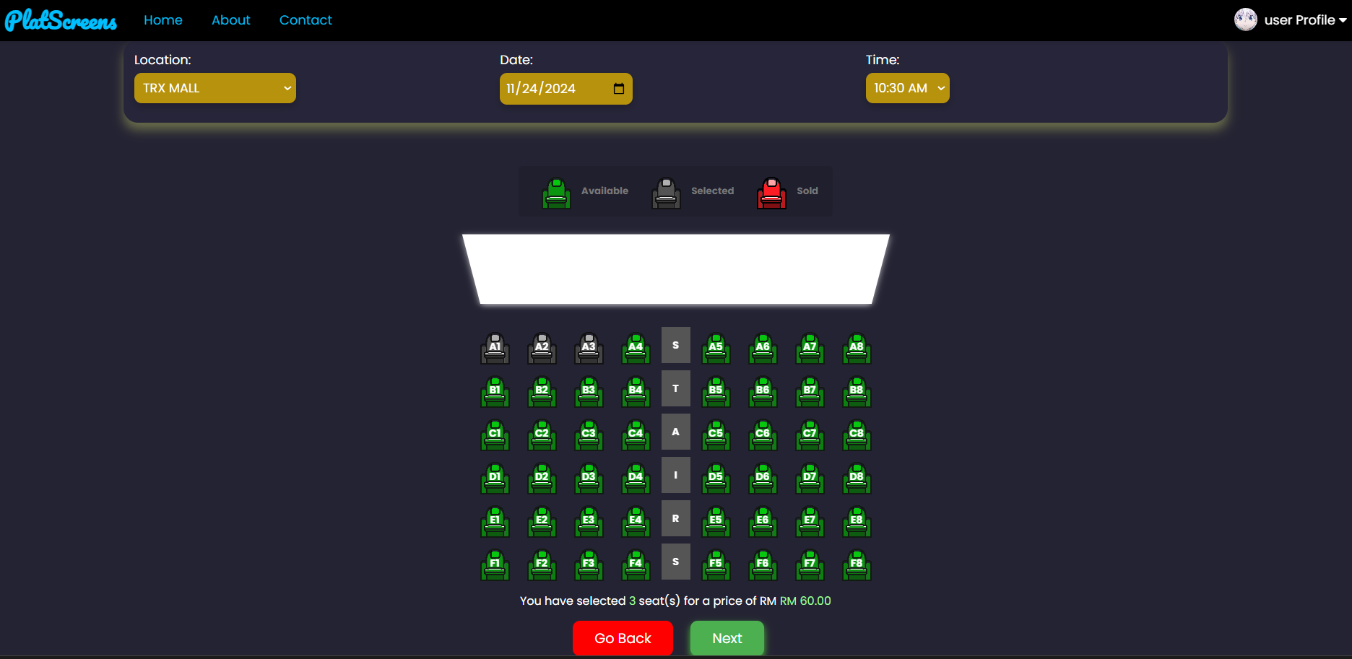

Figure 36:Seat selection in movie booking platform

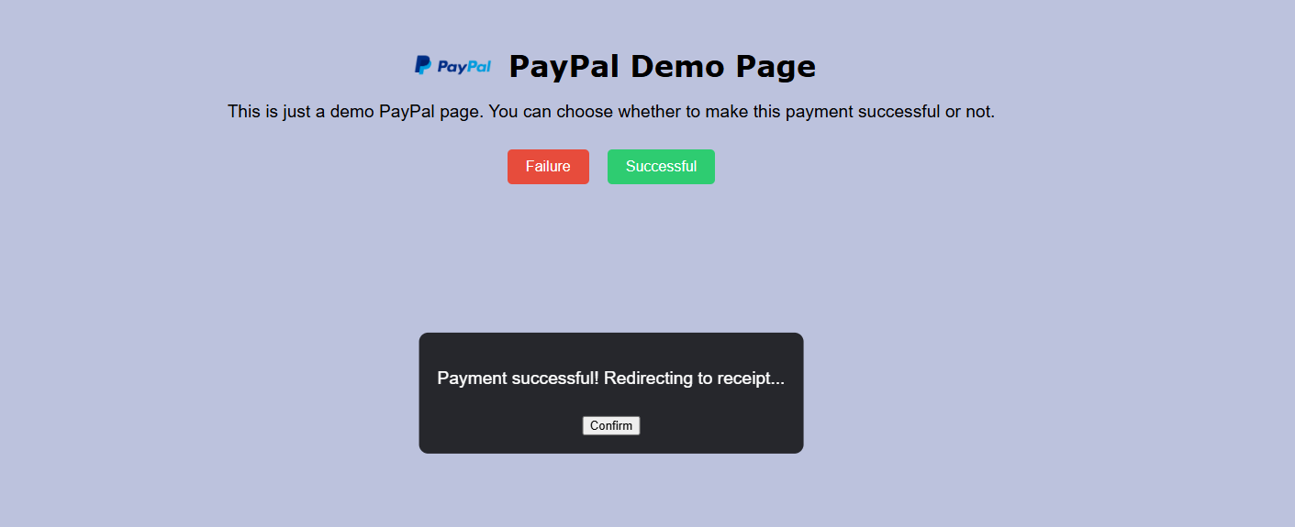

Figure 37:payment page

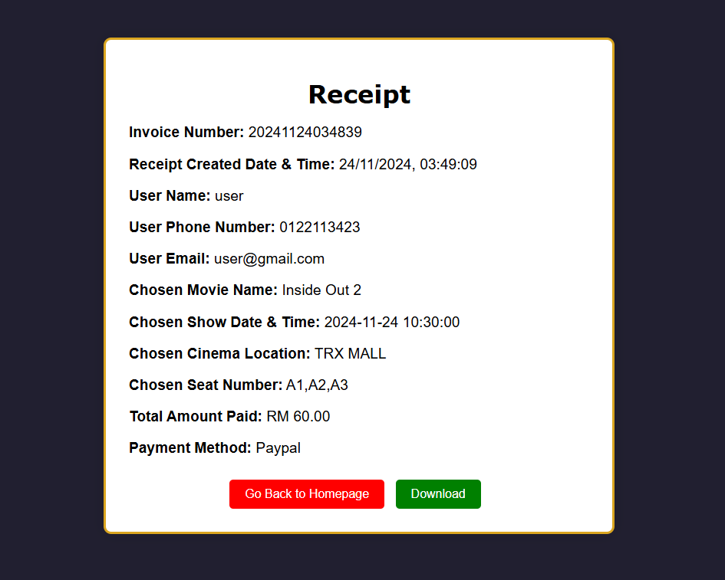

Figure 38:Confirmation of the payment with receipt

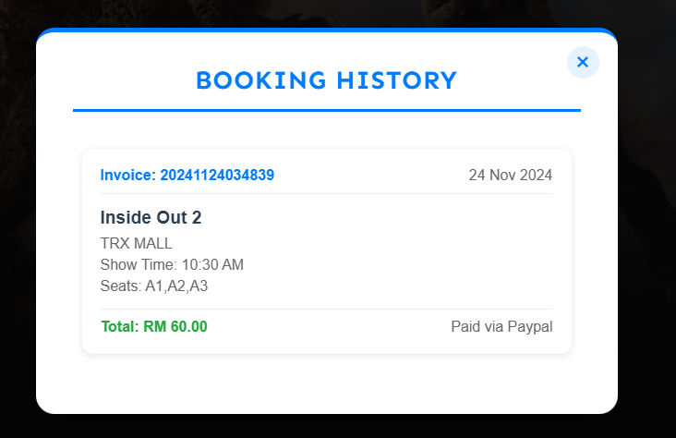

Figure 39:details of booking history

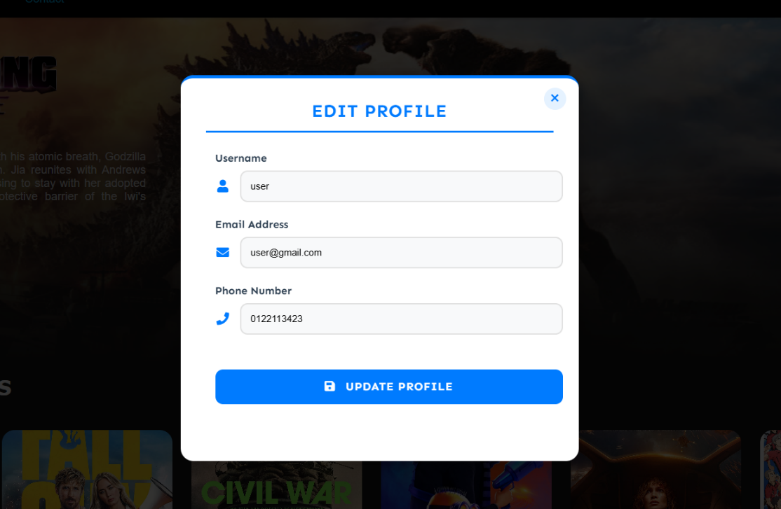

Figure 40:Editing user profile

* In the admin dashboard, ensure that you are allowed to see all the booking information made by customers, add new movie, update movie posters and information, update movie show dates/end dates, and remove movie from database.

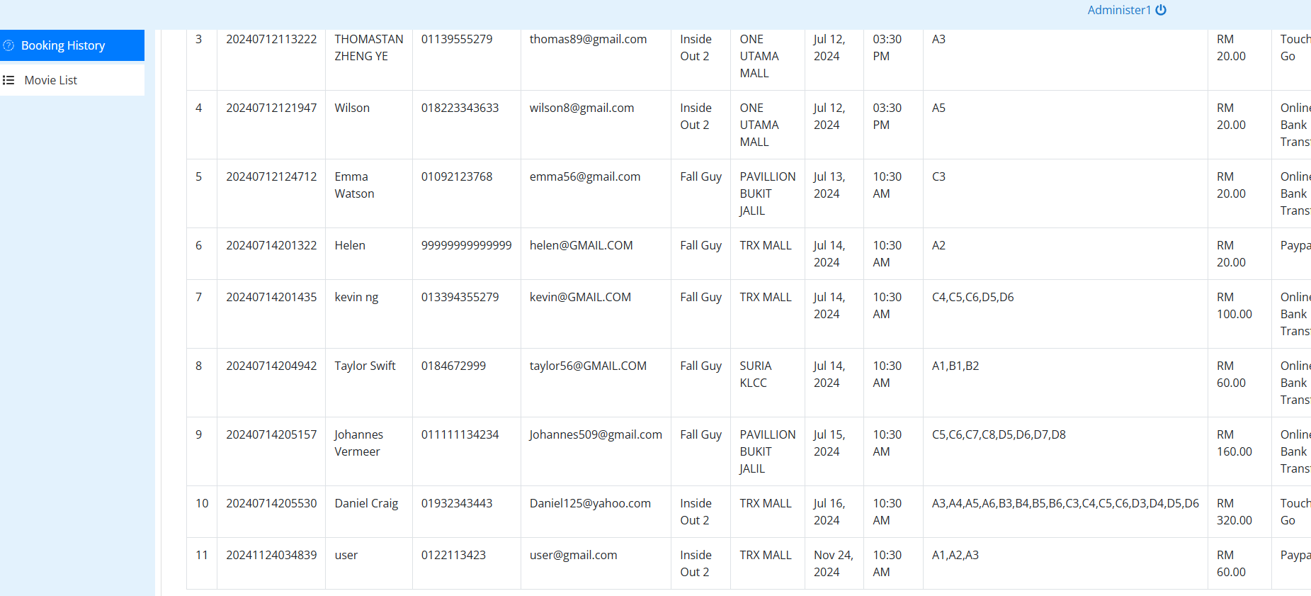

Figure 41:overview of admin dashboard

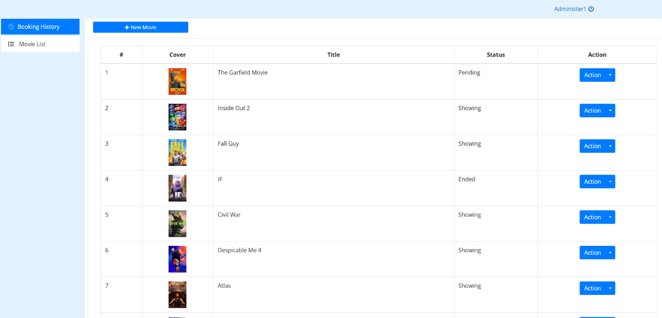

Figure 42:booking history in admin dashboard

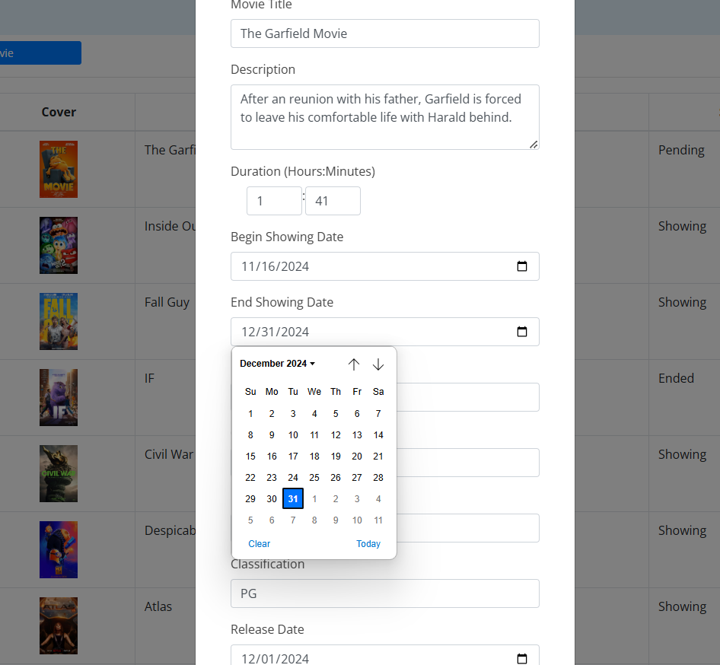

Figure 43:Admin uploading new movies

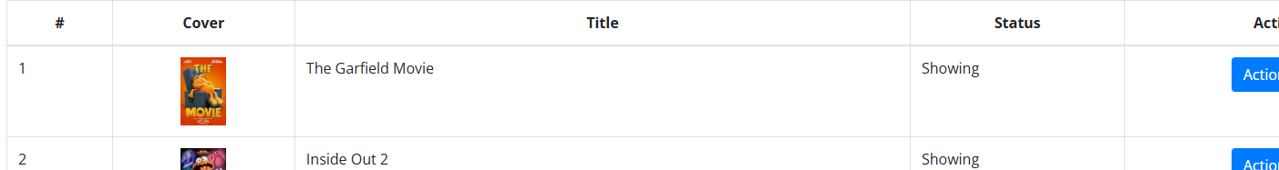

Figure 44:Movie being updated in the list

## Phrase 2: Decoupling the application components

**Task 1: Creating and configuring the Amazon RDS database**

1. At the top of the AWS Management Console, in the search bar, search for and choose EC2
2. In the navigation pane, choose **Security Groups**.
3. Choose **Create security group**, and configure the following:

* **Security group name**: Enter “CinemaWebDBSG”
* **VPC:** Choose **CinemaWebVPC**
* In the **Inbound rules** section, choose **Add rule** and configure the following:
  + **Type:** Choose **MYSQL/Aurora**.
  + **Source:** Enter 10.0.0.0/16 in the field to the right of **Custom**.
* Choose **Create security group**.

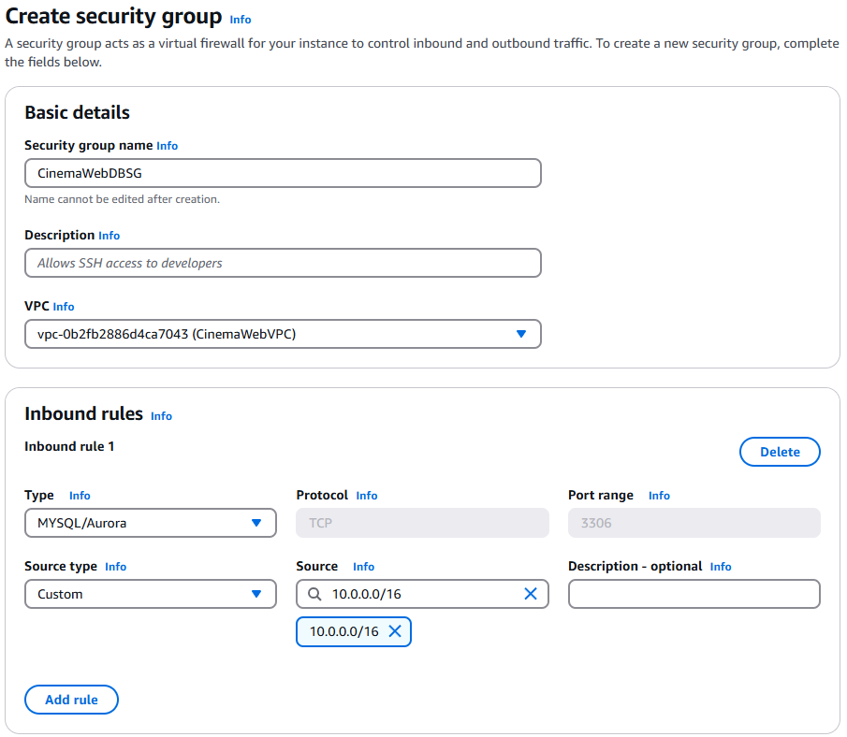

Figure 45: create security group for database

1. At the top of the AWS Management Console, in the search bar, search for and choose RDS, then choose “Subnet groups”
2. In the subnet groups page, click “create DB subnet group”
3. Give “CinemaRDS_SubnetGroup” as the name. Then, choose CinemaWebVPC as the VPC choice
4. Add 2 availability zones: ap-southeast-1a” & “ap-southeast-1b
5. Select subnets: Private subnet 3 & Private subnet 4.
6. Then click “Create”
7. At the left navigation pane on the RDS dashboard, choose Databases, then click “**Create database”**.
8. In the **Engine options** section, configure the following:

* **Engine type:** Choose **MariaDB**.
* In the **Templates** section, choose **Production**.
* In the **Settings** section, configure the following:
  + **DB instance identifier:** Enter “CinemaWebDB”
  + **Master username:** Enter “admin”
  + **Master password:** click **auto generate password** (remember to save)
* In the **Instance configuration** section, for **DB instance class**, choose “db.t4g.large”
* In the **Storage** section, for **Allocated storage**, enter 20 GiB.
* In the **Connectivity** section, configure the following:
  + **Virtual private cloud (VPC):** Choose **CinemaWebVPC**.
  + **Public access:** Choose **No**.
  + **VPC security group:** Keep **Choose existing** selected.
  + **Existing VPC security groups:** Remove the **default** group. Add the **CinemaWebDBSG** group.
  + **Availability Zone:** Choose “ap-southeast-1a” & “ap-southeast-1b”
  + **Subnet group:** choose CinemaRDS_SubnetGroup
* **Additional configuration** section, and for **Initial database name**, enter “theater_db”
* Choose **Create database**.

1. When the database is available, find and record the RDS database endpoint:

* From the list of databases, choose the **DB identifier** link for **CinemaWebDB**.
* On the **Connectivity & security** tab, under **Endpoint & port**, record the **Endpoint** value to use later.

**Task 2: Creating and configuring the S3 Bucket**

1. At the top of the AWS Management Console, in the search bar, search for and choose IAM.
2. Modify role setting:

* Choose **Role** on left navigation panel
* Choose “LabRole”
* Click “add permissions” > "attach policy”
* Search for **AmazonS3FullAccess** and check it
* click “attach policy”.

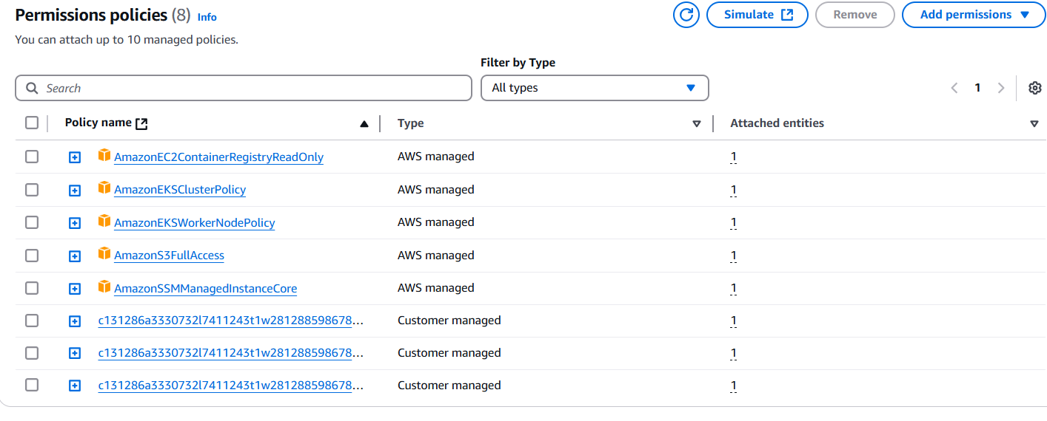

Figure 46: IAM Permission policies

1. At the top of the AWS Management Console, in the search bar, search for and choose S3.
2. Create S3 Bucket:

* Choose **Create bucket**
* **Bucket name**: “Cinema-Bucket”
* **Access Setting**: uncheck the “block all public access”
* Choose **Create bucket**

1. Choose bucket name we just created “Cinema-Bucket” and upload “images” folder from the zip file which include all images of the website to the bucket

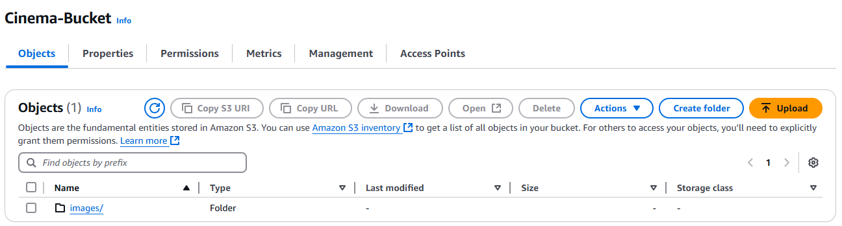

Figure 47: uploading images into the S3 bucket

1. Copy S3 bucket URL for later use.

**Task 3: Update Secrets Manager and Migrating the database**

1. Connect to EC2 instance, type following command:

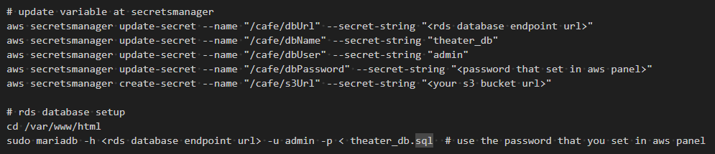

Figure 48:Connecting to Secret managers

1. After you have run the command, you can test the movie booking website.
2. Now, we can stop and remove the local database on original EC2 instance.

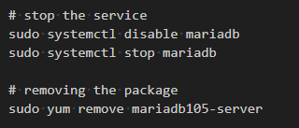

Figure 49: Stop and removal of local database from original ec2

**Task 4: Testing the application**

**User Web Page:**

Registration & Login: Test creating a new user account and logging in successfully.

Movie Information: Verify that you can see the most up-to-date movie information, including titles, descriptions, posters, and showtimes.

Booking: Try booking a movie ticket. Ensure the process is smooth and that you receive confirmation.

Booking History: Check your booking history to confirm that past bookings are displayed correctly.

User Profile Management: Access your profile, update your details, and change your password.

**Admin Dashboard:**

Booking Management: View all booking information made by customers.

Movie Management: Add new movies to the database.

Updating Movie Posters & Information: Modify movie posters and descriptions.

Updating Show Dates: Adjust the start and end dates for movie screenings.

Removing Movies: Delete movies from the database.

## A screenshot of a computer Description automatically generatedA screenshot of a video game Description automatically generatedPhase 3: Implementing high availability and scalability

Figure 50:Browsing of movie booking hisotry

Figure 51:Homepage of movie booking platform

**Task 1: Creating an Application Load Balancer**

1. At the top of the AWS Management Console, in the search bar, search for and choose EC2
2. In the navigation pane, choose **Load Balancers**.
3. Choose **Create load balancer**, and configure the following:

* In the **Load balancer types** section, for **Application Load Balancer**, choose **Create**.
* **Load balancer name**: enter “CinemaWebALB”
* In the **Network mapping** section, configure the following:
  + **VPC:** Choose **CinemaWebVPC**.
  + **Mappings:** Select both Availability Zones. The **Subnet** dropdown menu appears when an Availability Zone is selected.
  + **Subnet:** For each Availability Zone, select the public subnet 1 and public subnet 2.
* In the **Security groups** section, configure the following:
  + Choose **Create security group**.
  + **Security group name:** Enter “CinemaWeb-SG”
  + Choose **Add security group rule**.
  + **rule 1:** For **Type**, choose **HTTP**. For **Source type**, choose **Anywhere**.
  + **rule 2:** For **Type**, choose **SSH**. For **Source type**, choose **10.0.0.0/16**.
  + **rule 3:** For **Type**, choose **MYSQL/Aurora**. For **Source type**, choose **10.0.0.0/16**.
* In the **Listeners and routing** section, choose **Create target group**, which is located below the **Default action** field. A new tab or window opens.
  + In the new tab or window, configure the following:
    - **Choose a target type:** Choose **Instances**.
    - **Target group name:** Enter CinemaWebTG
    - **VPC:** Choose **CinemaWebVPC**.
    - **Health check path:** “/homepage/index.php”
    - Keep all other default settings and choose **Next**.
    - At the bottom of the page, choose **Create target group**.
    - Return to the tab or window where you started to create the load balancer.
* In the **Listeners and routing** section, choose the refresh icon, and then choose **CinemaWebTG** for **Default action**.
* Choose **Create load balancer**.
* Choose **View load balancer**.
* Record the **DNS name** for the load balancer. This name will be used as an endpoint to access the website later.

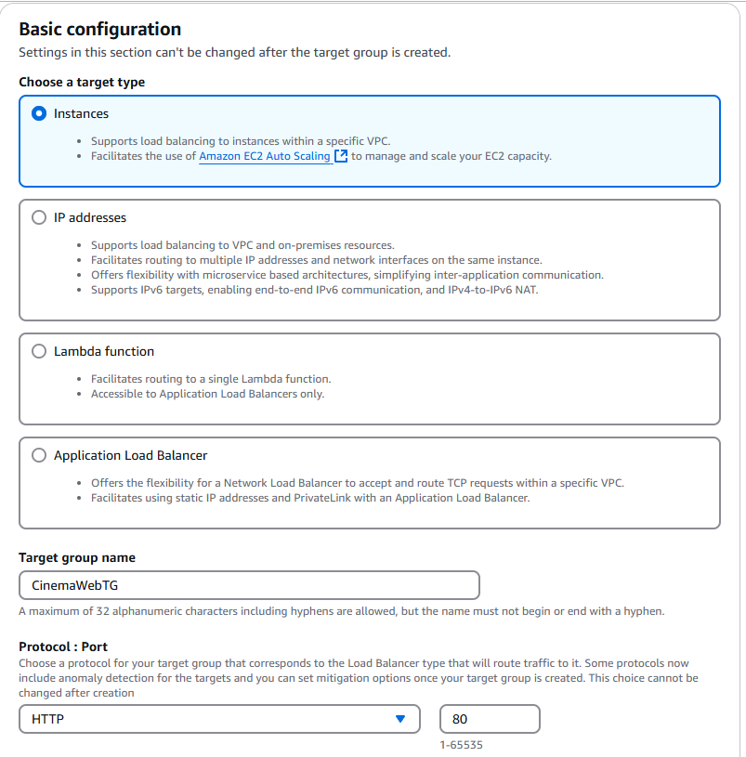

Figure 52: create target group for load balancer

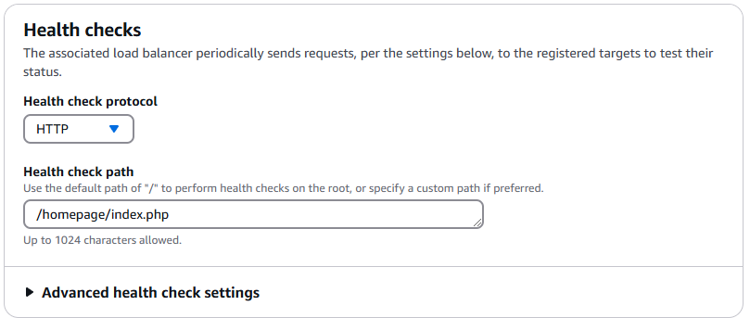

Figure 53: setting target group health check

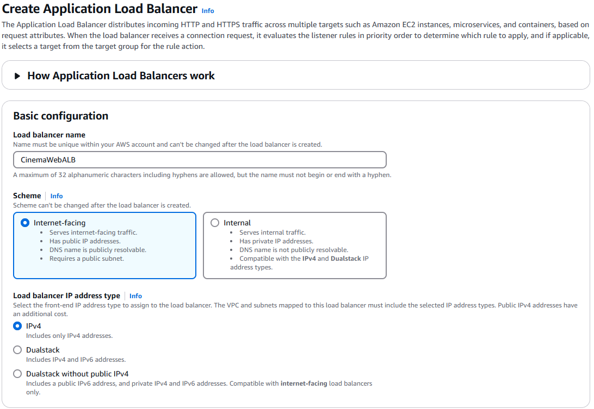

Figure 54: Load balancer setup 1

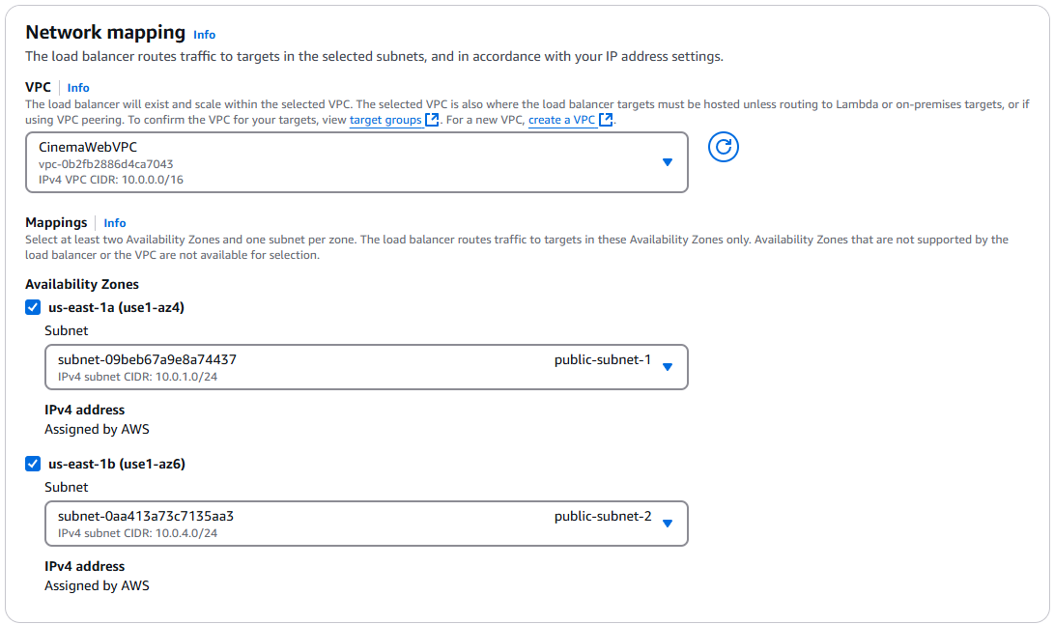

Figure 55: Load balancer setup 2

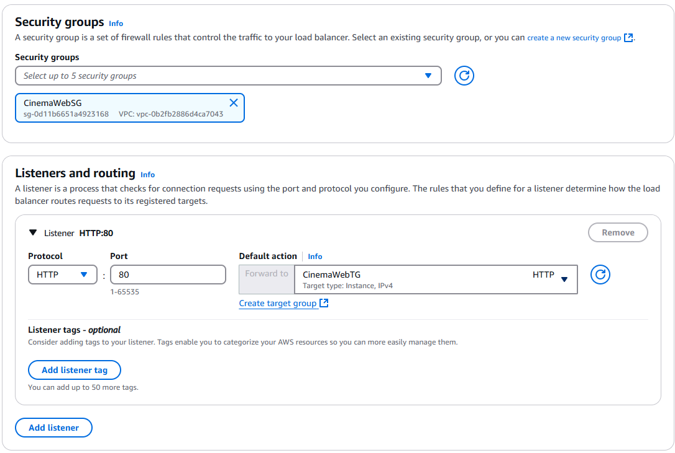

Figure 56: Load balancer setup 3

* After the load balancer was created, select the “Target group” from the left navigation pane.
* Now, choose “Cinema” and select Health checks at the bottom on the page.
* Select “Edit”.
* Expand the “advanced health check setting” and check the “turn on stickiness” for 1 days. (This allows load balancer to use cookies to ensure that all requests from particular user during a session are sent to the same target instance.)

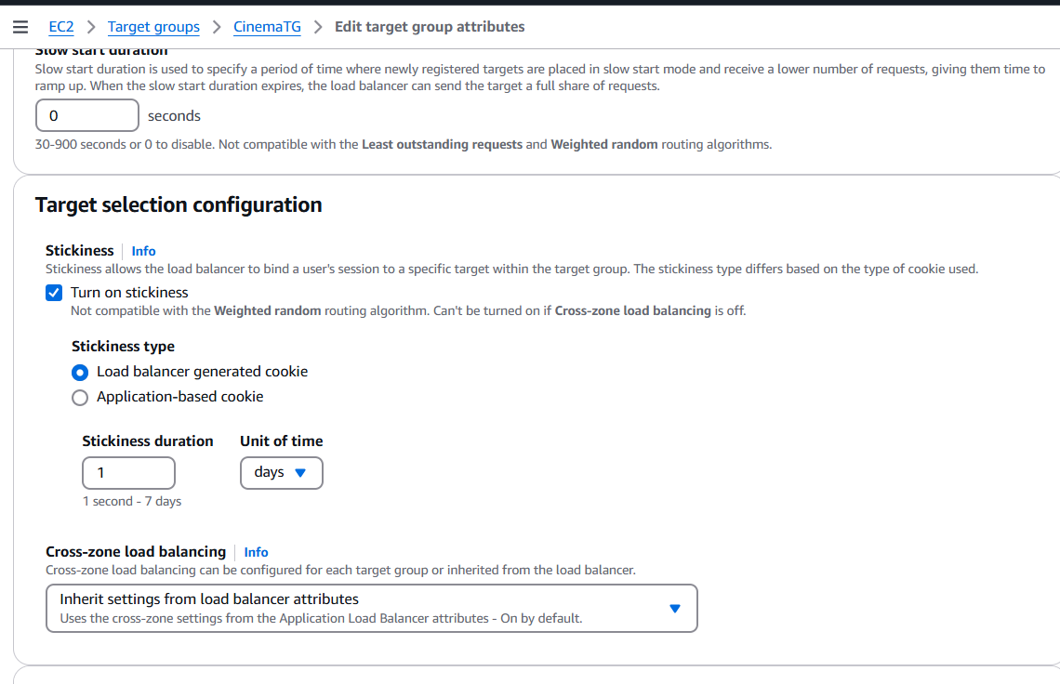

**Task 2: Implementing Amazon EC2 Auto Scaling**

1. Create an Amazon Machine Image (AMI) of the EC2 instance that hosts the web application, and use it to create the launch configuration for automatic scaling:

* In the navigation pane, choose **Instances**.
* From the list of instances, select the **CinemaDevServer** instance.
* Choose **Actions** > **Image and templates** > **Create image**.
* For **Image name**, enter **CinemaWebAMI**
* Choose **Create image**.
* In the banner at the top of the page, choose the link for the AMI name. A new tab or window opens and displays a list of AMIs.

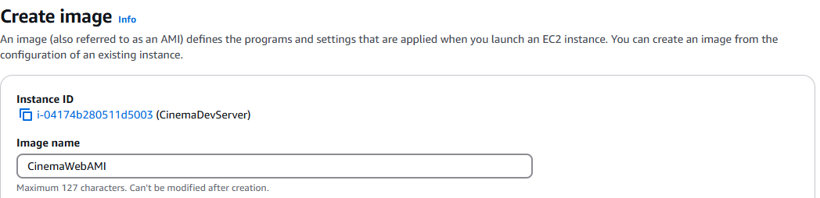

Figure 57: create AMI

1. Create a launch template:

* In the left navigation pane, under **Instances**, and choose **Launch Templates**.
* Choose **Create launch template**.
* In the **Launch template name and description** section, configure the following:
  + **Launch template name:** Enter “CinemaWebTemplate”
  + **Template version description:** “Web Server for Cinema”
  + **Auto Scaling guidance:** Select **Provide guidance to help me set up a template that I can use with EC2 Auto Scaling**.
* In the **Application and OS Images** section, choose **My AMIs**. Notice that **CinemaWebAMI** is already chosen.
* In the **Instance type** section, for **Instance type**, choose **“**t3.2xlarge**”**.
* In the **Key pair** section, create new key pair and enter key pair name “WebServerKey”. (remember to save the key pair file)
* In the **Network settings** section, for **Security groups**, select **CinemaWeb-SG**.
* Expand the **Advanced details** section.
* For **IAM instance profile**, choose **LabInstanceProfile**.
* Choose **Create launch template**.
* Choose **View launch templates**

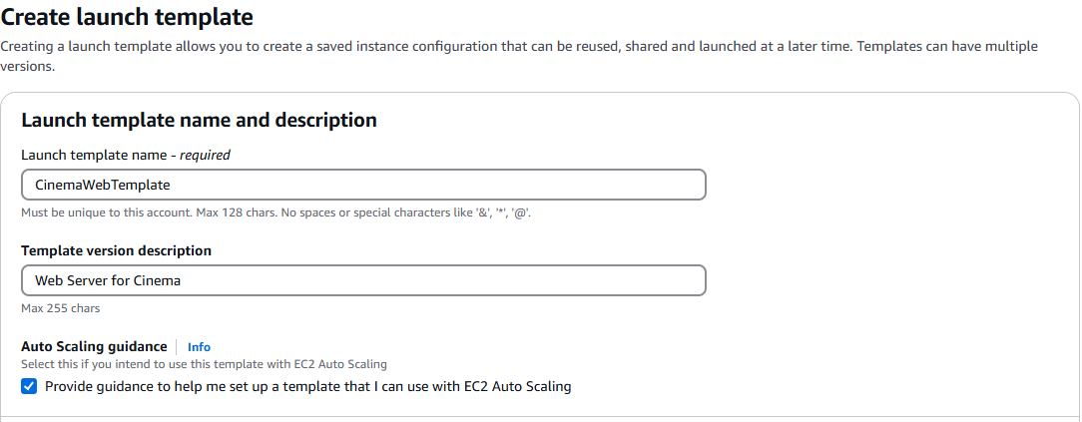

Figure 58: Create Launch Template 1

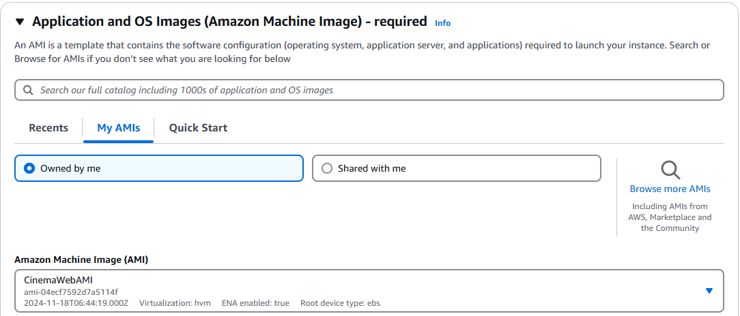

Figure 59: Create Launch Template 2

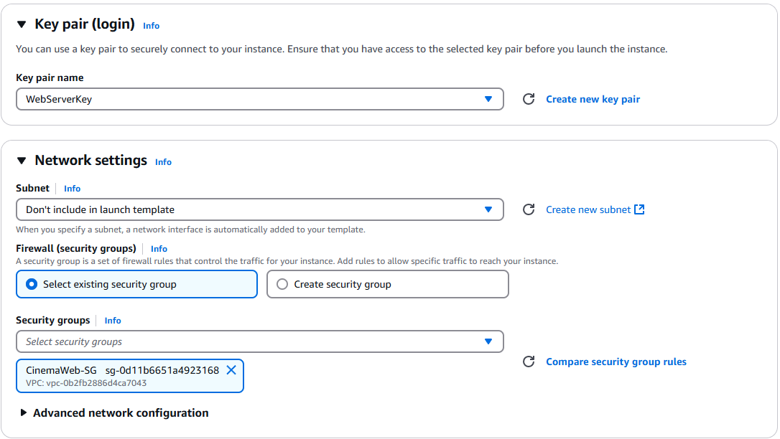

Figure 60: Create Launch Template 3

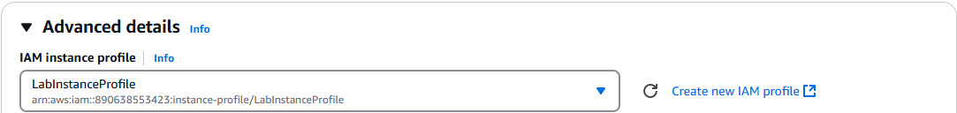

Figure 61: Create Launch Template 4

1. Create an Auto Scaling group:

* Choose **CinemaWebTemplate**, and then choose **Actions** > **Create Auto Scaling group**.
* Configure the following settings:
  + **Auto Scaling group name:** Enter “CinemaWebAutoScalingGroup”
  + Choose **Next**.
  + **VPC:** Choose **CinemaWebVPC**.
  + **Availability Zones and subnets:** Select ”Private Subnet 1” & “Private Subnet 2”.
  + Choose **Next**.
  + In the **Load balancing** section, choose **Attach to an existing load balancer**.
  + **Existing load balancer target groups:** Select **CinemaWebTG**.
  + In the **Health checks** section, for **Health check type**, select **ELB**.
  + Choose **Next**.
  + In the **Group size** section, configure the following:
    - **Desired capacity:** Enter 2
    - **Minimum capacity:** Enter 2
    - **Maximum capacity:** Enter 6
  + In the **Scaling policies** section, configure the following:
    - Choose **Target tracking scaling policy**.
    - **Metric type:** Choose **Average CPU utilization**.
    - **Target value:** Enter 50
    - Choose **Next**.
  + On the **Add notifications** page, choose **Next**.
  + Choose **Add tag**, and then configure the following:
    - **Key:** Enter “Name”
    - **Value:** Enter “Auto Scaling Instance”
    - Choose **Next**.
  + On the **Review** page, choose **Create Auto Scaling group**.

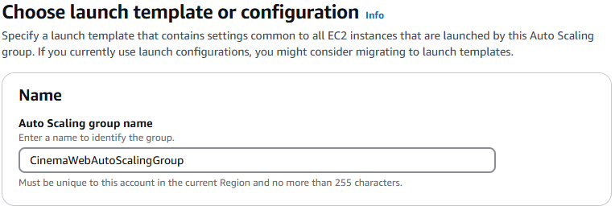

Figure 62: Create Auto Scaling Group 1

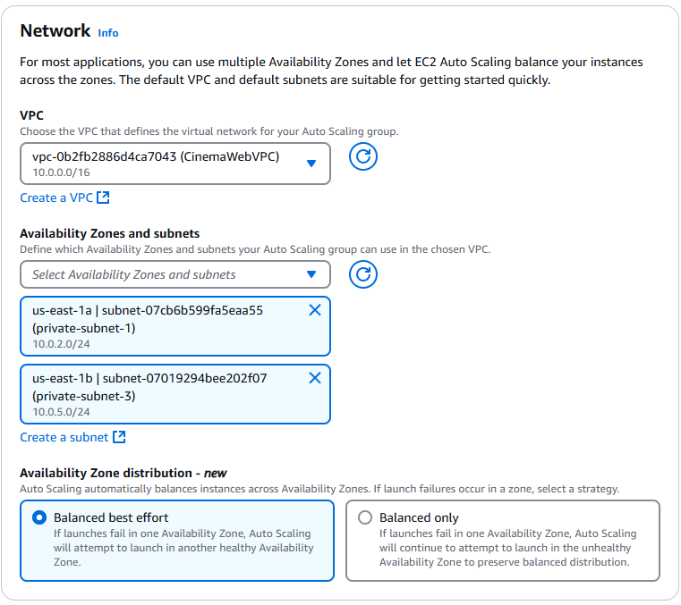

Figure 63: Create Auto Scaling Group 2

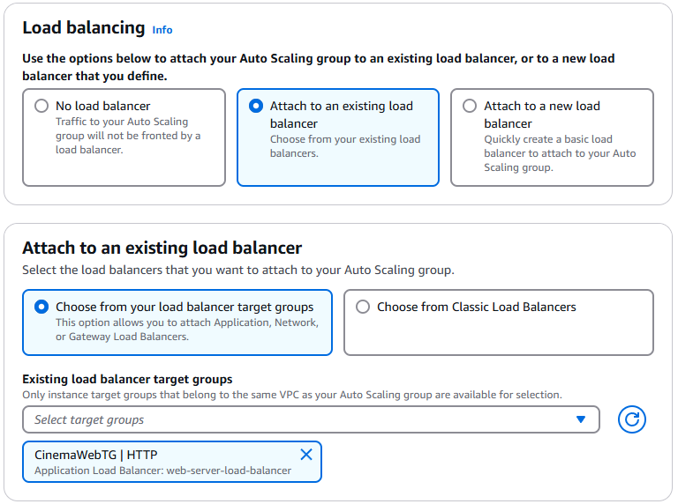

Figure 64: Create Auto Scaling Group 3

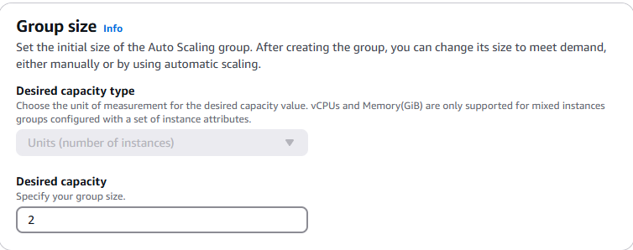

Figure 65: Create Auto Scaling Group 4

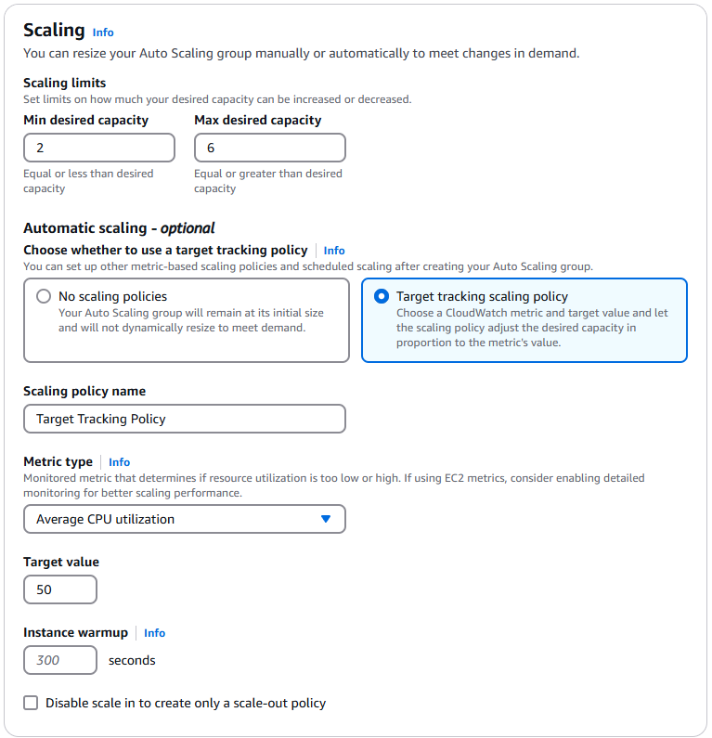

Figure 66: Create Auto Scaling Group 5

**Task 3: Accessing and Load testing the application**

1. Use the DNS name of the load balancer to access the web application.
2. Test the application functionality.
3. Run following command in ec2 instance (CinemaDevServer) to load test “ab -k -c 1000 -n 1000000 http://<LoadBalancerDNS>”
4. Navigate to the instances list in the Amazon EC2 console. Observe that the number of instances increases based on the load to the application.

# 3.0 Conclusion

We are so proud to have successfully assisted PLATSCREEN Cinema in hosting their movie booking website on the AWS cloud environment. This implementation enables their customers to seamleesly browse movie information, book tickets and interact with the web servers and RDS database to add, update, remove, create data. The AWS environment that we created can ensures a reliable and scalable infrastructure for enhancing user experience on using the website.

Through this project, we gained extensive knowledge of AWS cloud computing. We have learned how to design an architectural diagram that outlines the interactions between different AWS services based on the needs and conditions of the movie booking website. Moreover, We also get to explore different selection of regions and availability zones, different regions and availability zones, and choose the best options based on factors like latency, reliability, performance, and cost. Configuring essential components such as VPCs, subnets, route tables, NAT gateways, and internet gateways further strengthened our understanding of building secure and efficient network architectures.

Furthermore, we also evaluated multiple storage options in S3 and selected the most suitable storage types for the website ‘needs. Similarly, we compared various AWS database solutions to choose an option that can balance functionality, scalability, reliability, and cost considerations. By determining the optimal EC2 instance types, we ensured the deployment met the website’s performance requirements.

Besides, we deployed the PHP app on AWS and separating the web server and database to improve the efficiency and security of the environment. We configured network security settings to establish secure communication channels between the different components of the application.

In our project, we implemented a combination of load balancers and auto-scaling on AWS to ensure the high availability and scalability of our application. We configured load balancers to distribute incoming traffic across multiple instances, preventing any single server from becoming overloaded and maintaining responsiveness even during peak traffic periods. We also implemented auto-scaling to dynamically adjust the number of instances based on predefined metrics such as CPU utilization and request rate. This allowed our application to handle fluctuations in traffic effectively, scaling up when necessary and scaling down when traffic decreased.

This assignments enriched our experience on AWS cloud computing, and it allows us to navigate the complexities of cloud architecture and deployment while delivering a robust and efficient solution for PLANSCREEN cinema’s movie booking system.